Table of Contents

**Airplane Ticket Management System** 2

Database Planning 2

**Mission Objectives:** 2

**Mission Objective of Database:** 2

**PROJECT ERD:** 4

MUHAMMAD ADIL MEHMOOD (SP19-BCS-014) AND AYESHA LATIF (SP19-BCS-030) 4

**OBJECTIVE:** 4

**USER INTERFACES:** 6

**ERD DIAGRAM:** 9

Reviewed by: 9

**Comments:** 9

SYED HUZAIFA ABID (SP19-BCS-025) AND HAMZA MUSHTAQ (SP19-BCS-007) 9

**OBJECTIVE:** 9

**USER INTERFACES:** 10

**ERD DIAGRAM:** 12

**Comments:** 13

ADNAN KHURSHID (SP19-BCS-029) AND Zulkifil Rehman (SP19-BCS-027) 13

**OBJECTIVE:** 13

**USER INTERFACES:** 14

**ERD DIAGRAM:** 15

**Comments:** 16

ABDULLAH JAVED SP19-BCS-002 AND SAIF UR REHMAN (SP19-BCS-021) 16

**OBJECTIVE:** 16

**USER INTERFACES:** 17

ERD DIAGRAM: 17

**Reviewed by:** 18

**Comments:** 18

**GROUP**

# **Airplane Ticket Management System**

## **Database Planning**

We will divide our Airplane Ticket Management System into Following Sections.

### **Mission Objectives:**

*“The purpose of Airplane Ticket Management System is to allow stake-holders to easily pre-book flight tickets towards their destination and at time of their choice, they will be able to pre-plan there whole flight plan from meal selection to car-services at the departure terminal. The system will manage a user profile with the history of their reserved flights and in-depth budget details of the selections. System will auto-evaluate airplanes from passenger feedbacks and air customer support.”*

### **Mission Objective of Database:**

* To maintain (Enter, Update and Delete) data on Terminals
* To maintain (Enter, Update and Delete) data on Passengers
* To maintain (Enter, Update and Delete) data on Plane Customer Service Providers
* To maintain (Enter, Update and Delete) data on Bookings
* To maintain (Enter, Update and Delete) data on Finance
* To maintain (Enter, Update and Delete) data on Planes
* To maintain (Enter, Update and Delete) data on Available Seats
* To maintain (Enter, Update and Delete) data on Reserved / Booked Seats
* To maintain (Enter, Update and Delete) data on Cab Service
* To maintain (Enter, Update and Delete) data on Drivers
* To maintain (Enter, Update and Delete) data on Meals
* To maintain (Enter, Update and Delete) data on Feedback
* To Search on Routes
* To Search on Airplane Companies
* To Search on Cabs
* To Search on Terminals
* To Search on Airplane Customer Service Providers
* To track on Airplane
* To track on Reserved / Booked Seat
* To track on Available Seats
* To track on Reserved /Booked Seats
* To report on Airplane
* To report data on Customer Service Providers
* To report on Reservations
* To report on Cab Service
* To report on Terminal
* To report on Drivers

### **PROJECT ERD:**

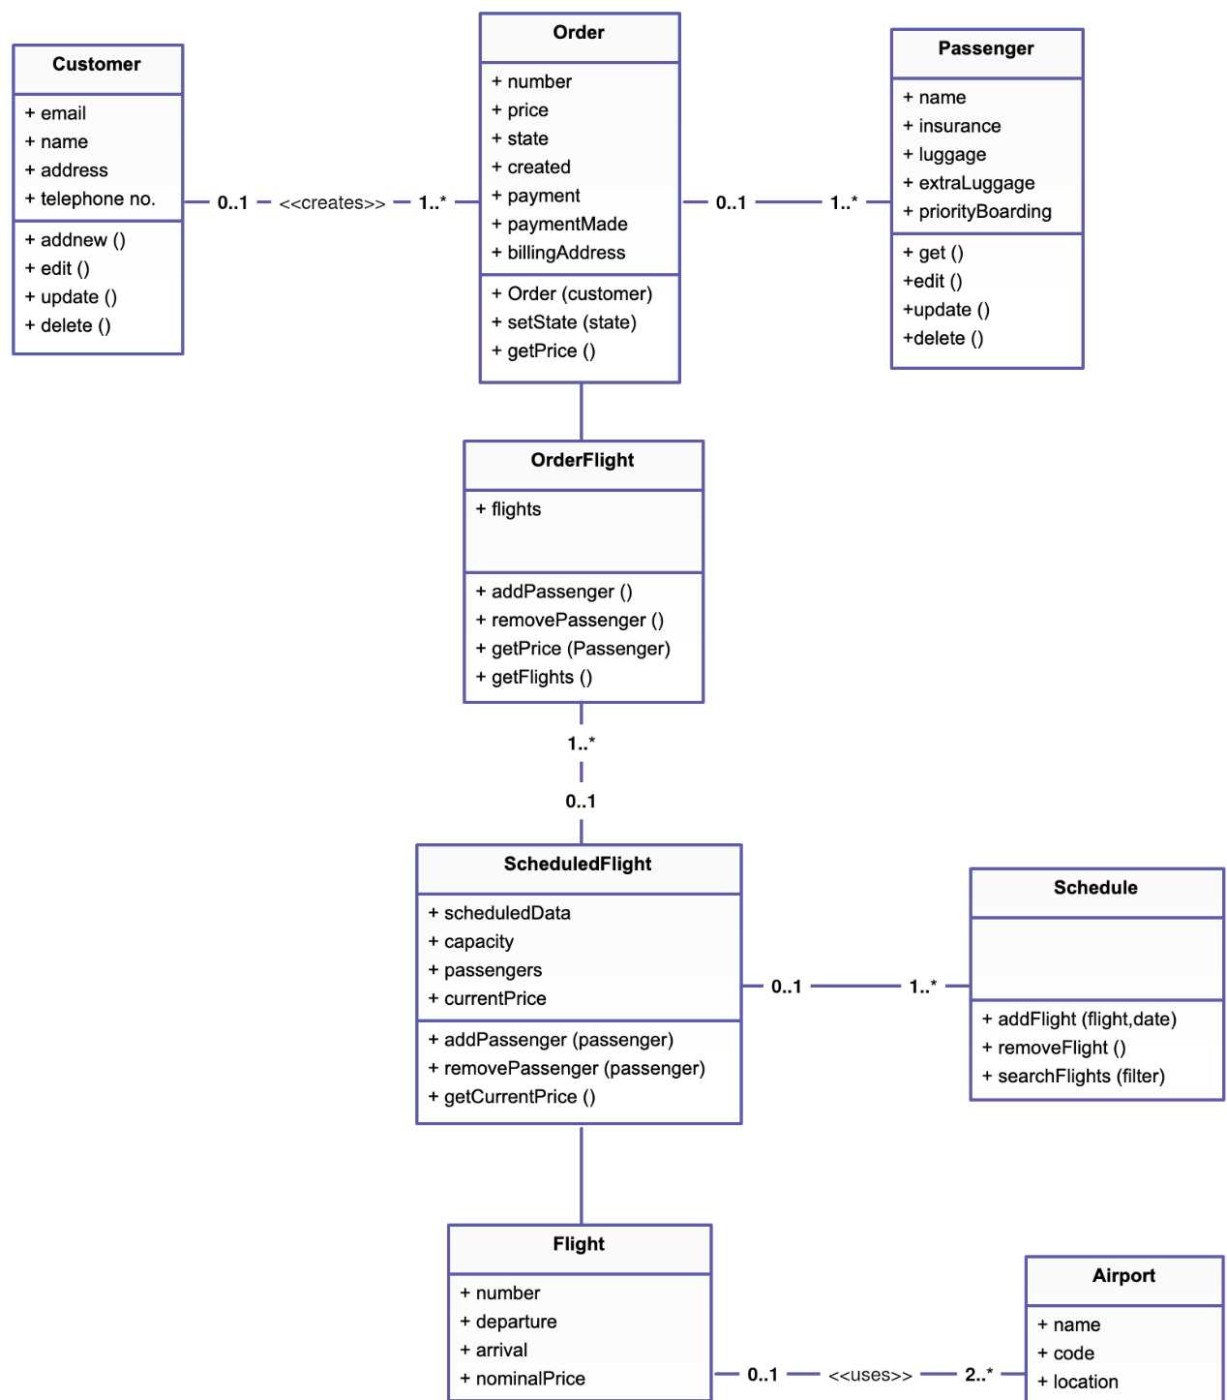

## **MUHAMMAD ADIL MEHMOOD (SP19-BCS-014)AND AYESHA LATIF (SP19-BCS-030)**

### **OBJECTIVE:**

We will be designing and developing panels for user and company profile management, these will further include edit profile sections, recent history of user interactions and also the main page with all the profile with recent bookings or planes listed there.

**Scope**

We will creat profile managament module of this app. In this module company creat his profile and edit it and alow user to creat his profile .Company add his information about his flight schedule and route details .

**Required time**

Required 2 months to be completed.

**Mission statement**:

We wil make profile management module .

**Complexity:**

We have to learn objact oriented concept of java .Beside we will use swing frame work of java .We face diificuties to use swing frame work. Because they dose not have wide community or extensive tutorials.

#### **Conclusion:**

#### In this module company can creat his profile and fucture plan.where administrator can Login into the application. Add flight, schedule and route details. View the flight, schedule and route details. Cancel or modify the flight, schedule and route details. User can creat his profile In this module where they easily updated about their flight schedule.

### **USER INTERFACES:**

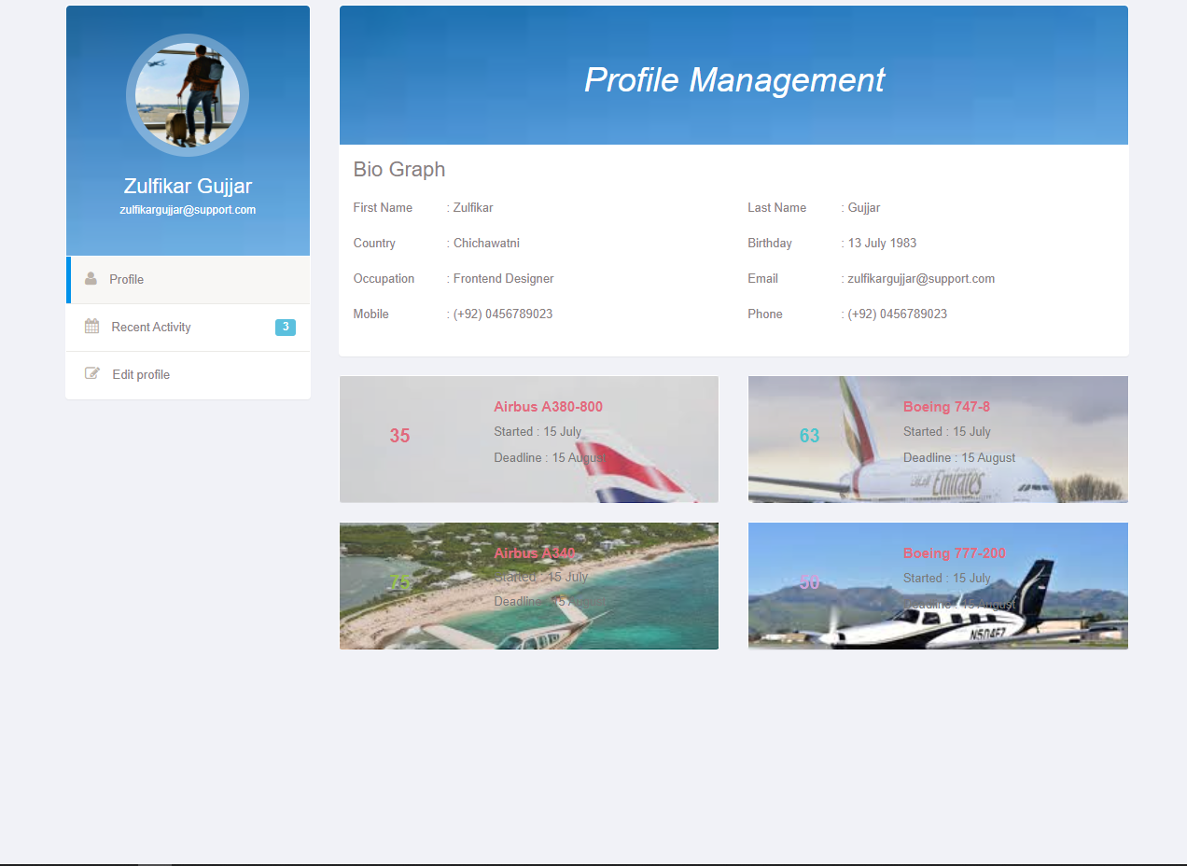

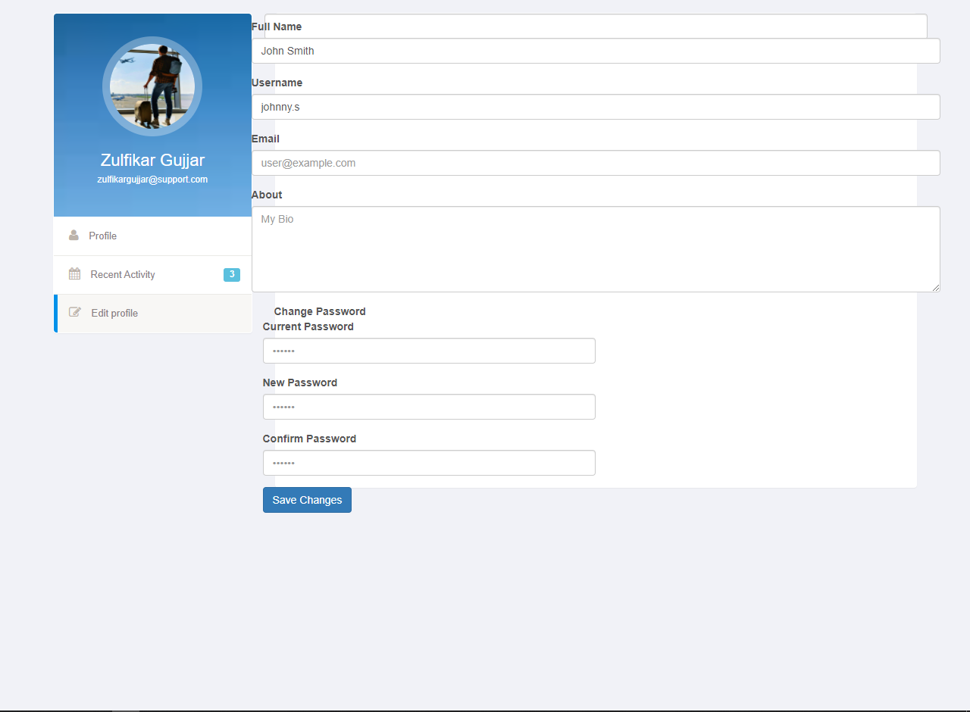

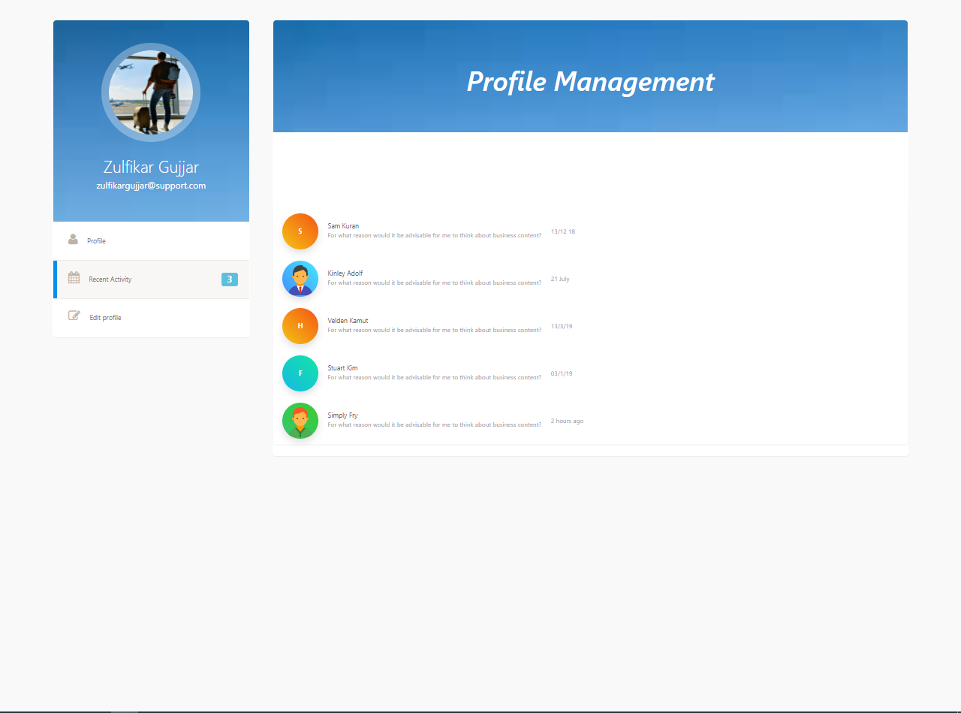

### **ERD DIAGRAM:**

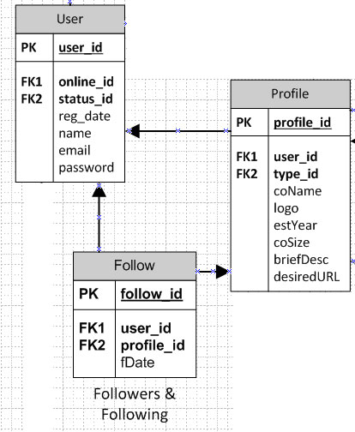

### **Reviewed by:**

Syed Huzaifa Abid(SP19-Bcs-025)

Zulkifil Rehman

# **Comments:**

Syed Huzaifa Abid: All ok!

Zulkifil rehman : Adil and ayesha did a great job by designing main panels and profile management system.

## **SYED HUZAIFA ABID (SP19-BCS-025) AND HAMZA MUSHTAQ (SP19-BCS-007)**

### **OBJECTIVE:**

* **Attractive interface (UI):**

Our main objective is to create an attractive and eye-catching interface for our user. An attractive interface compels user to stay for longer time.

* **To connect interface with database.**

Our next objective after UI design is to connect interface with database through JDBC (Java Database Connectivity).

* **To maintain integrity**

Integrity is the most vital part of any application. Our main focus would be secure our clients data and access restriction according to role of user.

* **To convey a complete ethical conduct of application.**

We will ensure our product will totally be used in ethical way and no illegal or mischievous activities are being conducted by our platform.

* **To provide a vivid view**

The view of login will be portraying a complete image on the client. The design will be clear.

* **Maintaining reliability**

We will ensure to maintain reliability of service to customer at a level above 99%.

**Time Required:**

Time required for development of this module is approximately **30 days** based on both volume of work and complexity.

### **USER INTERFACES:**

Splash Screen: Hides after 2 seconds.

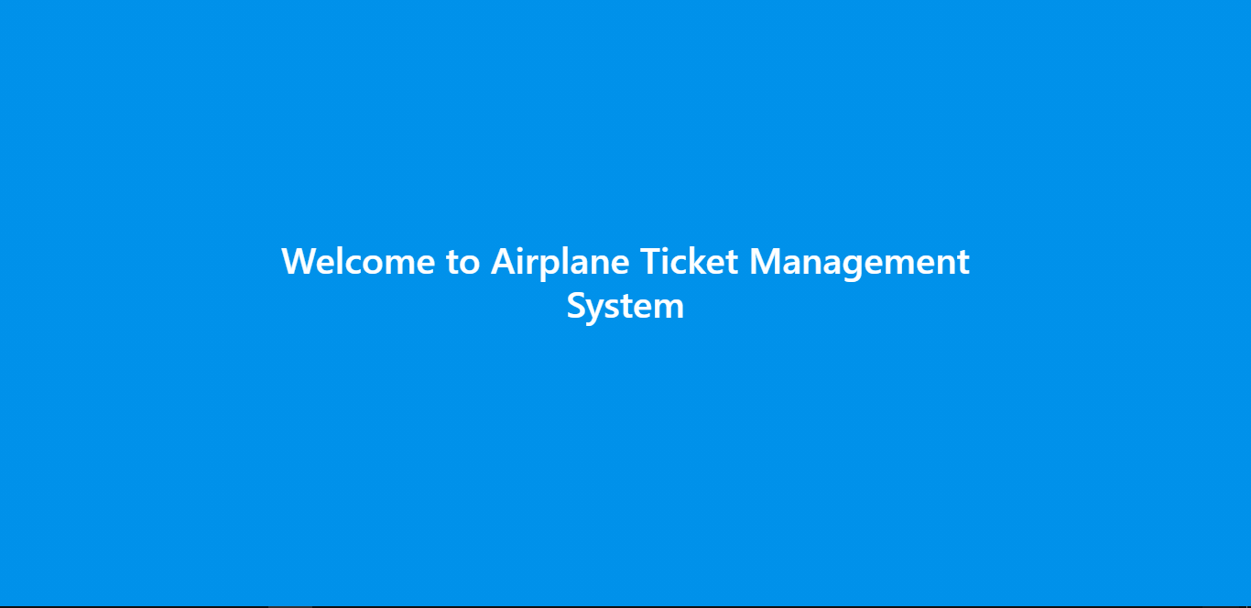

Sign In:

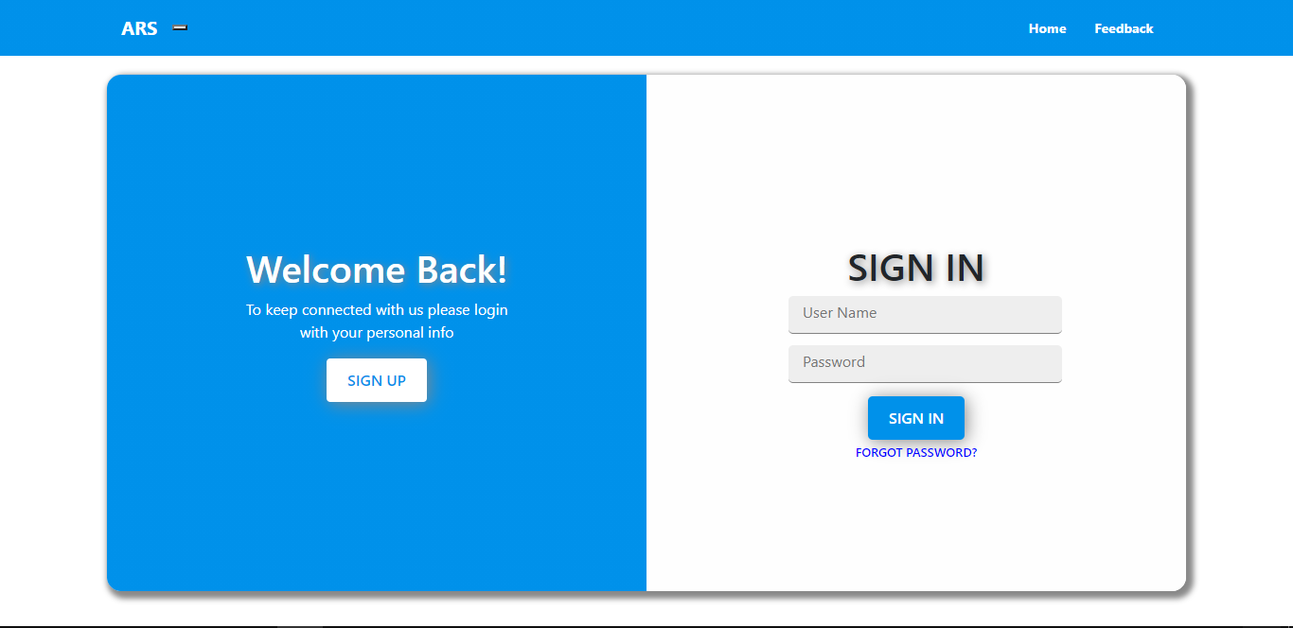

### **ERD DIAGRAM:**

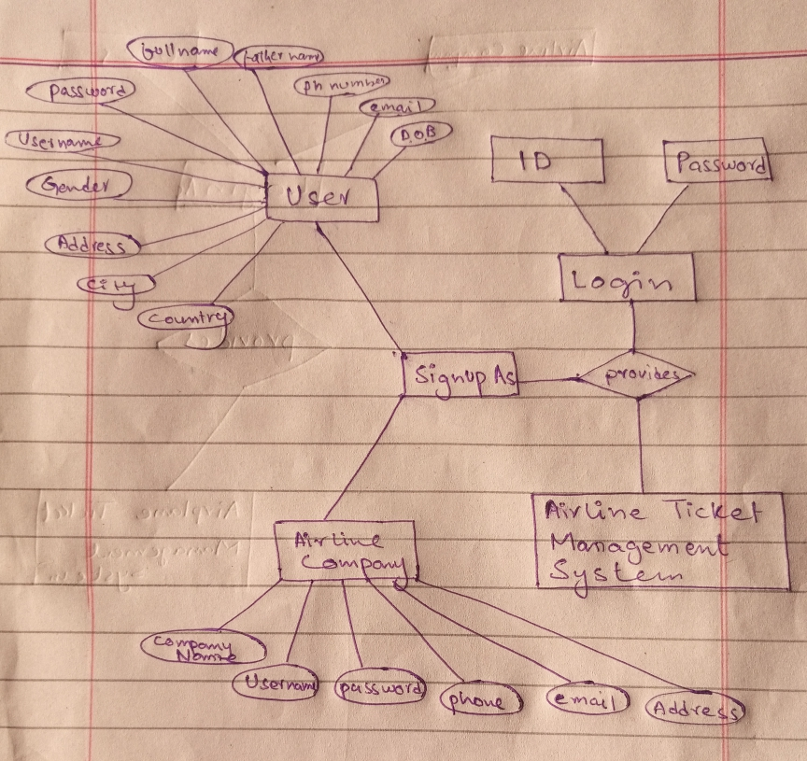

**Conceptual Database Modeling**

**SIGNUP AS**

* USER

-userName Primary Key (Contains Alphabets, Numbers,(.) and (_))

-password (Must contain atleast 8 alphanumeric characters)

-fullName (Only alphabets)

-fatherName (Only alphabets)

-phNumber Unique Key (Only Numbers and (+))

-email Unique Key (Alphanumeric characters)

-dateOfBirth (Numbers and (-))

-gender (Male, Female and others)

-address (Alpha Numeric)

-city (Alphabets)

-country (Alphabets)

* AIRLINE COMPANY

-userName Primary Key (Contains Alphabets, Numbers,(.) and (_))

-password (Must contain atleast 8 alphanumeric characters)

-companyName (Only alphabets)

-phone Unique Key (Only Numbers and (+))

-email Unique Key (Alphanumeric characters)

-address (Alpha Numeric)

### **Reviewed by:**

MUHAMMAD ADIL MEHMOOD (SP19-BCS-014)

Zulkifil Rehman

# **Comments:**

Adil: Objectives are added, prototype images are present, ERD diagrams present.

Zulkifil rehman : Hamza and hozaifa made login interface look great .

## **ADNAN KHURSHID (SP19-BCS-029) AND Zulkifil Rehman (SP19-BCS-027)**

### **OBJECTIVE:**

**Mission hope page**

**Time duration** 3 months

**Problem in task**

First we will learn java then oop then swing framework of java afterwards we will apply the given knowledge.

**Primary mission**

Main mission of homepage is to book ticket and get additional info such as

* Departing time and date
* Arriving time and date

**Secondary mission**

1. User can surf and see best deals on airline tickets that are available.
2. View top airlines
3. Email form
4. Client reviews
5. Methods of payment.

**Objectives**

1. We will design a UI search bar that displays airplane ticket details .store the details in myqsl and design it in html css,php .
2. Add logo
3. Add menu
4. Add email form and store data in mqsllibrary .

**Prototype**

**Flight (home page )**

**1 st section**

It would contain a simple flight search option . Which can contain flight from ,flight to ,departure ,returning .Here I have attached an example .

### **USER INTERFACES:**

**2 ndSection : Airline reviews**

**3 RD section footer**

**Conceptual Database Modeling**

Arrival_time( contains Alphabets, numbers, (:) )

Departure_time(( contains Alphabets, numbers, (:) )

Price (( contains Alphabets, numbers, (.) )

Flight_number(( contains Alphabets, numbers,)

Destination ( only Alphabets)

Departure( only Alphabets)

### **ERD DIAGRAM:**

|  |  |
| --- | --- |
| **Flight** | |
| Arrival_time | Varchar(50) |
| Departure_time | Varchar(50) |
| Price | Varchar(255) |
| Flight_number | Varchar(255) |
| Destination | Varchar(255) |
| Departure | Varchar(50) |
| Arrival | Varchar(50) |

### **Reviewed by:**

MUHAMMAD ADIL MEHMOOD (SP19-BCS-014)

Syed Huzaifa Abid(SP19-Bcs-025)

# **Comments:**

Objectives are added, prototype images are present, ERD diagrams present.

All ok!

## **ABDULLAH JAVED SP19-BCS-002 AND** [**SAIF UR REHMAN (SP19-BCS-021)**](bookmark://_Toc54156995)

### **OBJECTIVE:**

Forms are used in at least three places in the application to fetch the data from the user. the code snippet of feedback form that’s embedded in” Contact Us” page. The feedback form is declared and the fields are defined.

A small form called Feedback Form can be found in the “Contact Us” page. The users can send in their feedbacks to the company using this form. The form contains five fields where the users can enter their name, email address, service quality, rate out of five stars and message. The data from Feedback Form after sending is saved into company’s database. Below shows the view of Feedback Form.

Contact us

Feedback form

Your name

__________________

Email address

__________________

Services quality (tick one of the following)

Excellent, V. Good, Good, Satisfactory

Rate out of five stars

*****

Your Message

### **USER INTERFACES:**

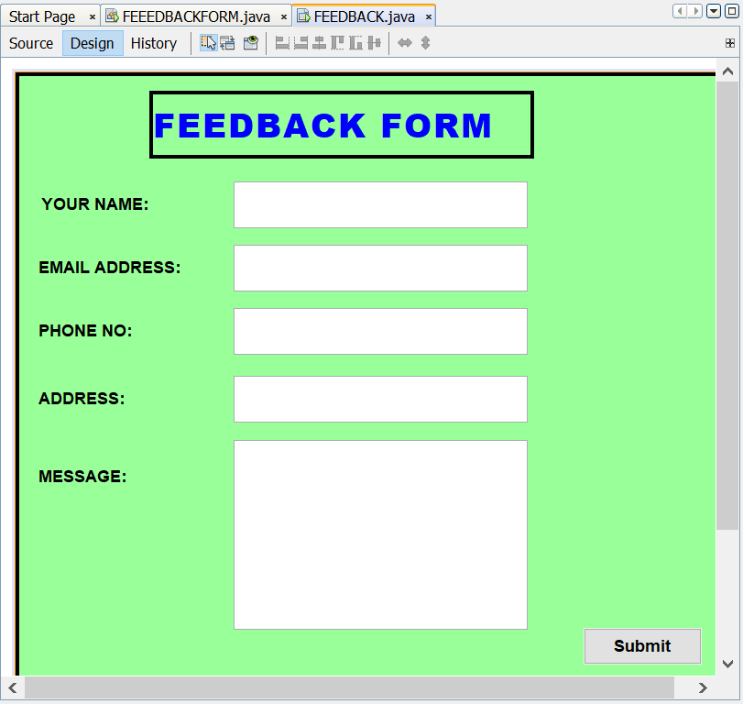

## **ERD DIAGRAM:**

|  |  |
| --- | --- |
| FEEDBACK | |
| userName | Varchar(255) |
| phone | Varchar(255) |
| email | Varchar(20) |
| address | Varchar(255) |

FEEDBACK FORM

RATE THE SERVICE PROVIDER (ATMS APP)

AIRLINE SERVICE QUALITY

NAME, EMAIL ADDRESS

INPUT FROM USER

### **Reviewed by:**

Syed Huzaifa Abid(SP19-BCS-025)

Zulkifil Rehman

# **Comments:**

All ok!

Zulkifil rehman :saif and Abdullah did a great job by working on feedback module .